Table 1 – customer
create table customer (
cust_id number(5) primary key,
name varchar(20) not null,
mob_no number(10) not null,
email varchar(30) not null,
city varchar(20) not null
);

insert into customer
values(1, 'Parshwa', 1234567890, 'parshwa@gmail.com', 'Surat');
insert into customer
values(2, 'Neev', 1234586890, 'neev@gmail.com', 'Surat');
insert into customer
values(3, 'Vansh', 3234567890, 'vansh@gmail.com', 'Surat');
insert into customer
values(4, 'Tirth', 3234567590, 'tirth@gmail.com', 'Surat');
insert into customer
values(5, 'Neel', 13434567890, 'neel@gmail.com', 'Surat');

Table 2 – orders
create table orders (
order_id number(5) primary key,
cust_id number(5) references customer(cust_id),
order_date date not null,
total_amt number(10,2),
order_status varchar(30) check (order_status in('Pending', 'Completed'))
);

insert into orders
values(1, 1, '10/02/2026', 1000, 'Completed');
insert into orders
values(2, 2, '11/02/2026', 2000, 'Completed');
insert into orders
values(3, 3, '11/02/2026', 1500, 'Completed');
insert into orders
values(4, 4, '12/02/2026', 1200, 'Pending');
insert into orders
values(5, 5, '13/02/2026', 3000, 'Pending');

Table 3 – payment
create table payment (
payment_id number(10),
payment_date date not null,
mode_of_payment varchar(15) check (mode_of_payment in('UPI', 'Cash', 'Pending')),
amount number(10,2),
order_id number(5) references orders(order_id)
);

insert into payment
values(101, '10/02/2026', 'UPI', 1000, 1);
insert into payment
values(102, '11/02/2026', 'Cash', 2000, 2);
insert into payment
values(103, '11/02/2026', 'Cash', 1500, 3);
insert into payment
values(104, '12/02/2026', 'Pending', 1200, 4);
insert into payment
values(105, '13/02/2026', 'Pending', 3000, 5);

Q.1 Write SQL Query to display Total Amount spent by each Customer.
select cust_id, sum(total_amt) from orders group by cust_id;
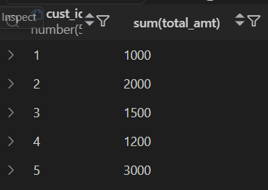

Q.2 Write SQL Query to show Customer Name and Order details where order status is Completed.
select c.cust_id, c.name, o.order_status, o.total_amt from customer c join orders o on c.cust_id = o.cust_id where o.order_status = 'Completed';
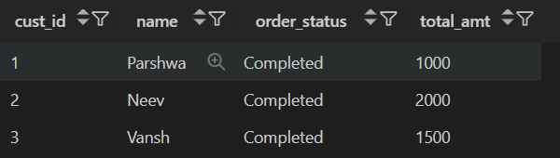
Q.3 Write a SQL Query to display which customer has made Payment in Cash and Total amount paid by them.
select c.cust_id, c.name, p.mode_of_payment, sum(p.amount) from customer c join orders o on c.cust_id = o.cust_id join payment p on o.order_id = p.order_id where p.mode_of_payment = 'Cash';


Q.4 Write SQL Query to display customers who placed orders above average order amount.
select * from orders where total_amt > (select avg(total_amt) from orders);
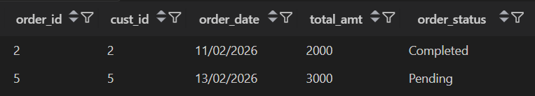

Q.5 Write PL/SQL block to print the sum of first N Natural Numbers.
DECLARE
n number(5);
i number;
total_num number := 0;
BEGIN
n:=:n;
for i in 1..n loop
total_num := total_num + i;
end loop;
dbms_output.put_line('Sum of first N Numbers : ' || total_num);
END;
Sum of first N Numbers : 55
PL/SQL procedure successfully completed.
Q.6 Write PL/SQL program to check whether the Year Entered by the user is Leap Year or Not.
DECLARE
v_pay payment%rowtype;
BEGIN
v_pay.order_id:=:order_id;
select * into v_pay from payment where order_id = v_pay.order_id;
IF v_pay.order_id >= 1 and v_pay.order_id <= 5 THEN
v_pay.payment_id:=:payment_id;
IF v_pay.payment_id >= 101 and v_pay.payment_id <= 105 THEN
dbms_output.put_line('Payment ID: ' || v_pay.payment_id);
dbms_output.put_line('Payment Date: ' || v_pay.payment_date);
dbms_output.put_line('Mode of Payment: ' || v_pay.mode_of_payment);
dbms_output.put_line('Amount: ' || v_pay.amount);
dbms_output.put_line('Order ID: ' || v_pay.order_id);
ELSE
dbms_output.put_line('Invalid payment ID for the given order ID.');
END IF;
ELSE
dbms_output.put_line('No payment found for the given order ID.');
END IF;
END;
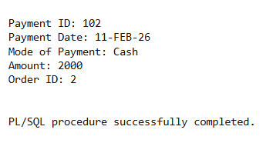

Q.7 Write PL/SQL program to check whether the payment id entered is between range or not. If the entered id is outside the given range then raise user-defined exception NO_PAYMENTID_FOUND.
DECLARE
v_pay payment%rowtype;
NO_PAYMENTID_FOUND EXCEPTION;
BEGIN
v_pay.payment_id:=:payment_id;
select * into v_pay from payment where payment_id = v_pay.payment_id;
if v_pay.payment_id >= 101 and v_pay.payment_id <= 105 THEN
dbms_output.put_line('Payment ID: ' || v_pay.payment_id);
dbms_output.put_line('Payment Date: ' || v_pay.payment_date);
dbms_output.put_line('Mode of Payment: ' || v_pay.mode_of_payment);
dbms_output.put_line('Amount: ' || v_pay.amount);
dbms_output.put_line('Order ID: ' || v_pay.order_id);
ELSE
RAISE NO_PAYMENTID_FOUND;
END IF;
EXCEPTION
WHEN NO_PAYMENTID_FOUND THEN
dbms_output.put_line('No payment found for the given payment ID.');
END;

